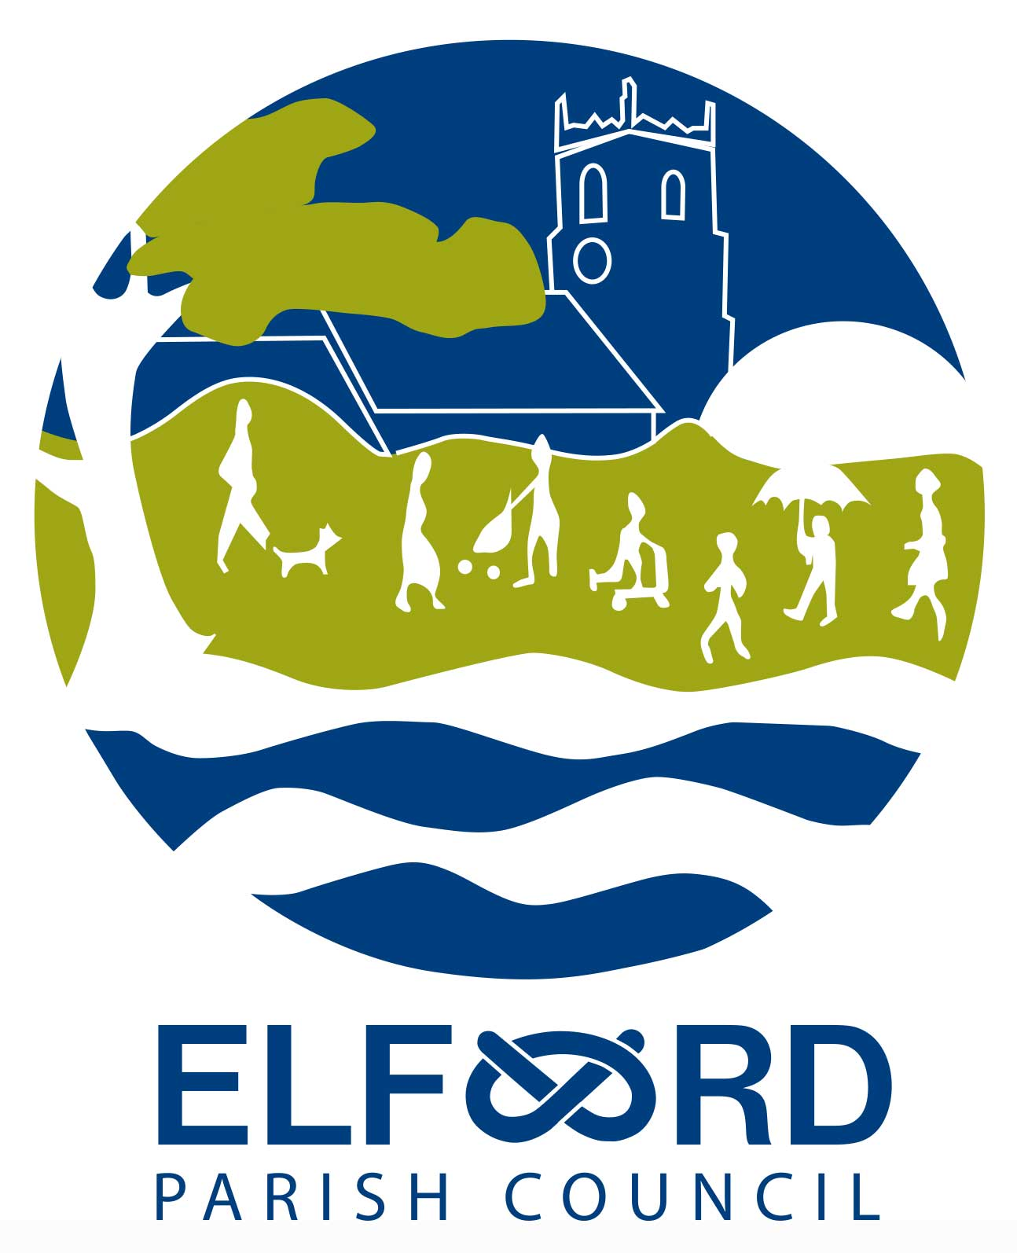 Meeting of the Parish Council

Tuesday 12th October 2021, 7 pm,
at Elford Village Hall

A G E N D A

Open Forum – to receive any questions or comments from residents.

To receive Apologies for absence

To receive Declarations of Interest

To approve the Minutes of the Meeting of 13th September 2021

To receive the Clerk’s Report

To consider any Planning Matters:

Applications

Update on the Social Club site

CIL payments

To receive an update on development of land at The Shrubbery

To consider Scoping Report for Playground Funding

To consider Playground maintenance and outcomes of Annual Inspection

To consider an event to mark HM The Queen’s Platinum Jubilee

- To consider Forward Planning

- To receive Questions and Reports from Councillors

- To receive Correspondence

- To receive a Financial Report

- To consider authorising Schedule of Accounts for payment

- Date of Next Meeting : Monday 8th November at 7pm, Elford Village Hall

