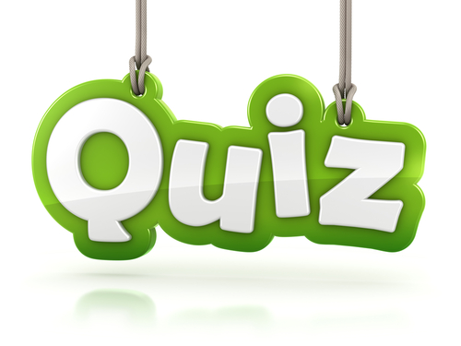
At The Crown
Elford
A General Knowledge Quiz
on
Monday, February 13th 2017
at 7.15 for 7.45 pm start
Teams of 4
£8 per person including food

During the interval Light Refreshments
will be served for each table

Tickets from The Crown 01827 383602
or Sue: 01827 383487/Barbara: 01827 383567

In aid of St Peter’s Church, Elford
with proceeds of a raffle going to
The Howard School Classroom Project

