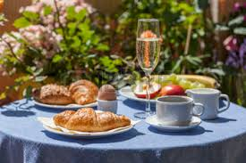

Celebrate the Queen’s birthday

with us!

Church – but not as you know it!

A less formal style of worship.

Sunday 5th June 2016

9.30 – 11am

Elford Village Hall

When did you last have a champagne breakfast with

ice-cream?